**SVKM’s NMIMS**

**School of Technology Management & Engineering, Chandigarh**

A.Y. 2023 - 24

**Course: Database Management Systems**

**Project Report**

|  |  |  |
| --- | --- | --- |
| Program | MBA TECH DS | |
| Semester | 4 | |
| Name of the Project: | HOSPITAL RECORDS ANALYSIS PROJECT | |
|  | | |
| Details of Project Members |  |  |
| Batch | Roll No. | Name |
| J3 | S052 | Shantanu Sinha |
| J3 | S057 | Soham Hande |
| J3 | S068 | Mahek Mistry |
| J3 | S069 | Anushka Naik |
| Date of Submission: 01-04-2024 | | |

**Contribution of each project Members:**

|  |  |  |
| --- | --- | --- |
| Roll No. | Name: | Contribution |
| S052 | Shantanu Sinha | Fetching and organizing the data set, ER diagram and report |
| S057 | Soham Hande | SQL – running queries, ER diagram and report |
| S068 | Mahek Mistry | SQL – creating tables, ER diagram and report |
| S069 | Anushka Naik | Relational Model, ER diagram and report |

**Github link of your project:**

**Note:**

1. Create a readme file if you have multiple files
2. All files must be properly named (Example:R004_DBMSProject)
3. Submit all relevant files of your work ( Report, all SQL files, Any other files)
4. **Plagiarism is highly discouraged (Your report will be checked for plagiarism)**

**Rubrics for the Project evaluation:**

|  |  |
| --- | --- |
| First phase of evaluation:  Innovative Ideas (5 Marks)  Design and Partial implementation (5 Marks) | 10 marks |
|  |  |

**Project Report**

**HOSPITAL DATABASE MANAGEMENT**

**by**

**Shantanu Sinha, Roll number: 52**

**Soham Hande, Roll number: 57**

**Mahek Mistry, Roll number: 68**

**Anushka Naik, Roll number: 69**

**Course: DBMS**

**AY: 2023-24**

**Table of Contents**

|  |  |  |
| --- | --- | --- |
| **Sr no.** | **Topic** | **Page no.** |
| **1** | Storyline | 5 |
| **2** | Components of Database Design | 6 |
| **3** | Entity Relationship Diagram | 10 |
| **4** | Relational Model | 11 |
| **5** | Normalization | 12 |
| **6** | SQL Queries | 13 |
| **7** | Project Demonstration | 23 |
| **8** | Self-learning beyond classroom | 23 |
| **9** | Learning from the project | 24 |
| **10** | Challenges faced | 25 |
| **11** | Conclusion | 26 |

**I. Storyline**

In today's healthcare landscape, hospitals face numerous challenges in providing quality care while optimizing operational efficiency. To address these challenges, hospitals are increasingly turning to data-driven approaches to improve patient outcomes and streamline processes. In this narrative, we explore how a hospital leverages SQL operations on its dataset to enhance patient care and operational performance.

A Hospital Database Management System plays a vital role in modern healthcare organizations by streamlining administrative processes, optimizing resource utilization, and improving patient care. By fulfilling the requirements outlined in this storyline, the DBMS empowers hospitals to deliver efficient and high-quality healthcare services while ensuring patient safety, satisfaction, and well-being.

**II. Components of Database Design**

1 . Patients

* Patient_id (Primary key)
* Patient_Name
* Age
* Sex
* Address
* P_Contact

2. Departments

* Department_id (Primary key)
* HeadDoctor_id
* Department_Name

3. Doctors

* Doctor_id (Primary key)
* Doctor_Name
* Specialization
* Department_id
* D_Contact

4 . Appointments

* Appointment_id (Primary Key)
* Doctor_id
* Patient_id
* A_Date
* A_Time
* Status

5 . Beds

* Bed_id (Primary Key)
* Department_id
* Status

6 . Medications

* Medication_id (Primary Key)
* Med_Name
* Manufacturer
* Unit Price

7. Prescriptions

* Prescription_id (Primary key)
* Patient_id
* Doctor_id
* Medication_id
* P_date

8. Dependents (weak entity)

* Patient_id
* Dependant_Name
* Contact
* Relationship

**Relationships:**

* One Patient can have multiple Appointments. (Patient to Appointment: One-to-Many)
* One Doctor can have multiple Appointments. (Doctor to Appointment: One-to-Many)
* One Department can have multiple Doctors. (Department to Doctor: One-to-Many)
* One Patient can have multiple Prescriptions. (Patient to Prescription: One-to-Many)
* One Doctor can prescribe multiple Medications in different Prescriptions. (Doctor to Prescription: One-to-Many)
* One Medication can be prescribed in multiple Prescriptions. (Medication to Prescription: One-to-Many)
* One Patient can have multiple Dependents. (Patient to Dependent: One-to-Many)

**Cardinality and Participation:**

* Patient-Appointment: Mandatory Participation from Patient side, Optional Participation from Appointment side. (1:N)
* Doctor-Appointment: Mandatory Participation from Doctor side, Optional Participation from Appointment side. (1:N)
* Department-Doctor: Mandatory Participation from Department side, Mandatory Participation from Doctor side. (1:N)
* Patient-Prescription: Mandatory Participation from Patient side, Optional Participation from Prescription side. (1:N)
* Doctor-Prescription: Mandatory Participation from Doctor side, Optional Participation from Prescription side. (1:N)
* Medication-Prescription: Mandatory Participation from Medication side, Optional Participation from Prescription side. (1:N)
* Patient-Dependent: Mandatory Participation from Patient side, Optional Participation from Dependent side. (1:N)

**III. Entity Relationship Diagram**

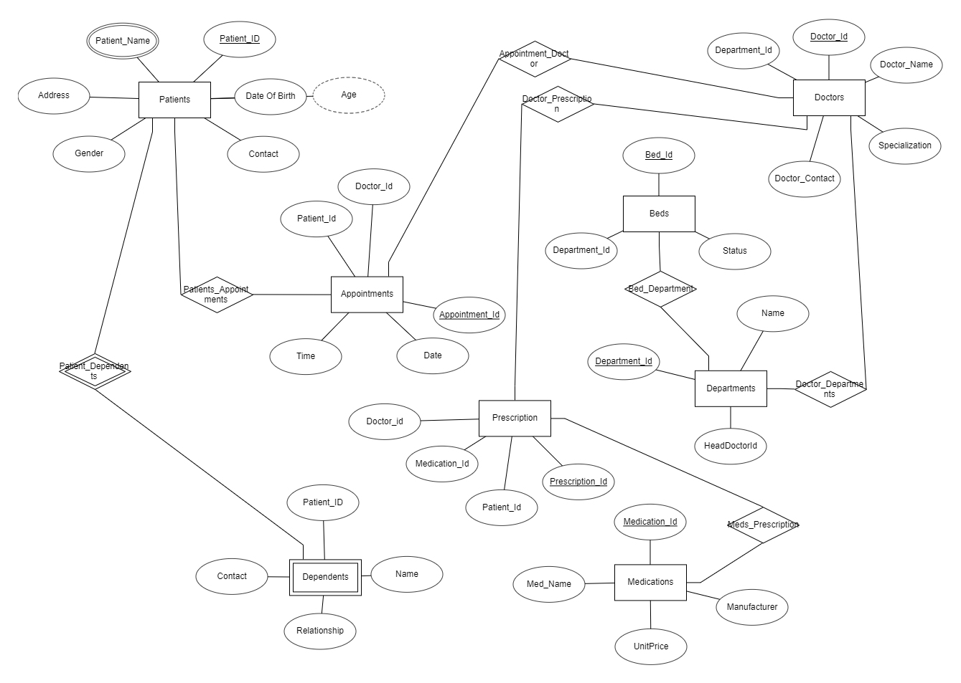

**IV. Relational Model**

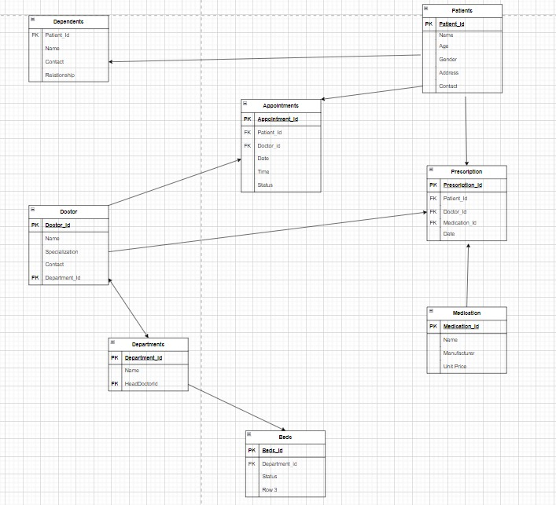

**V. Normalization**

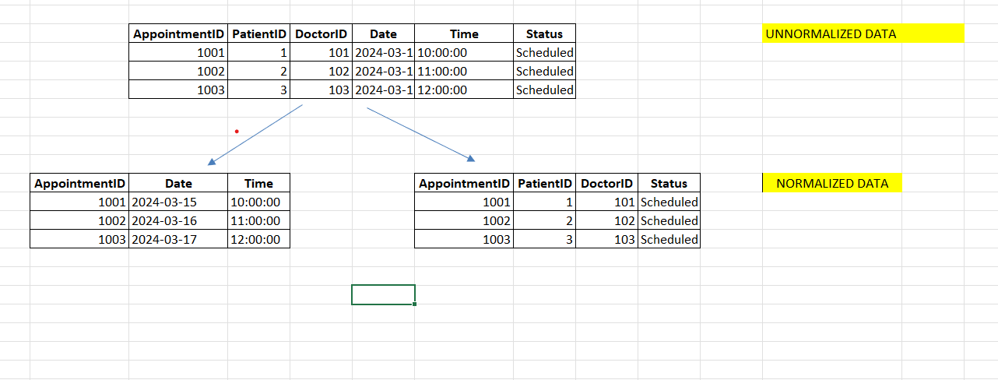

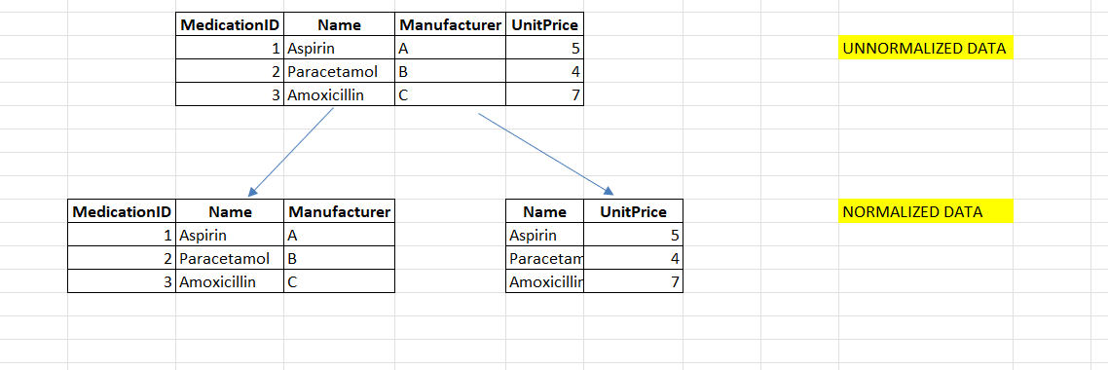

**VI. SQL Queries (created tables)**

**PATIENTS**

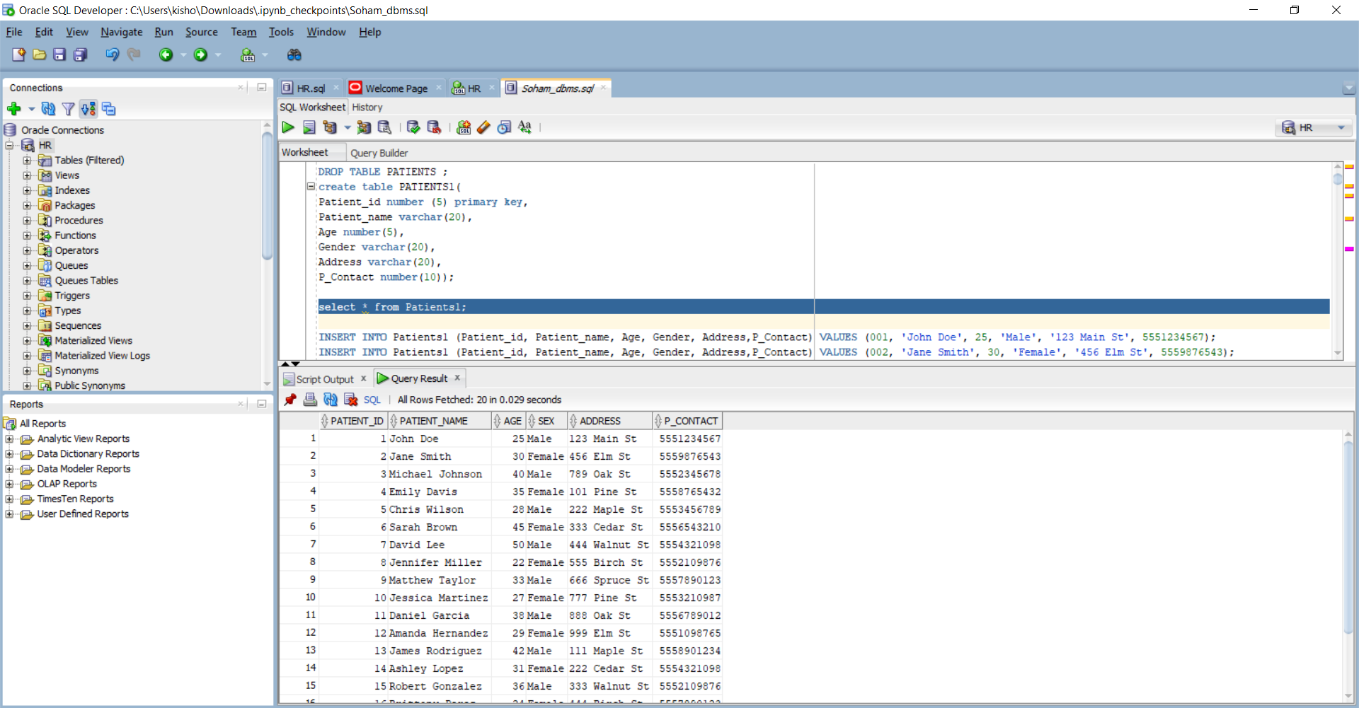

**DEPARTMENTS**

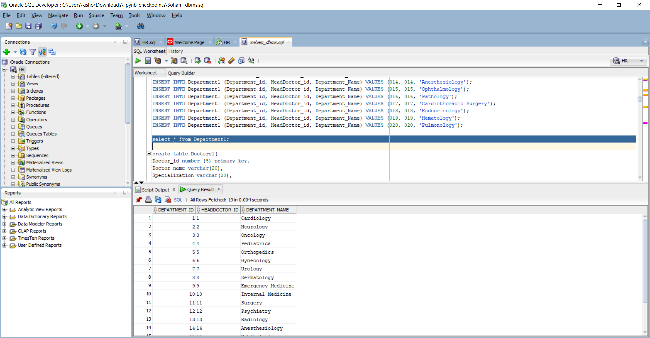

**DOCTORS**

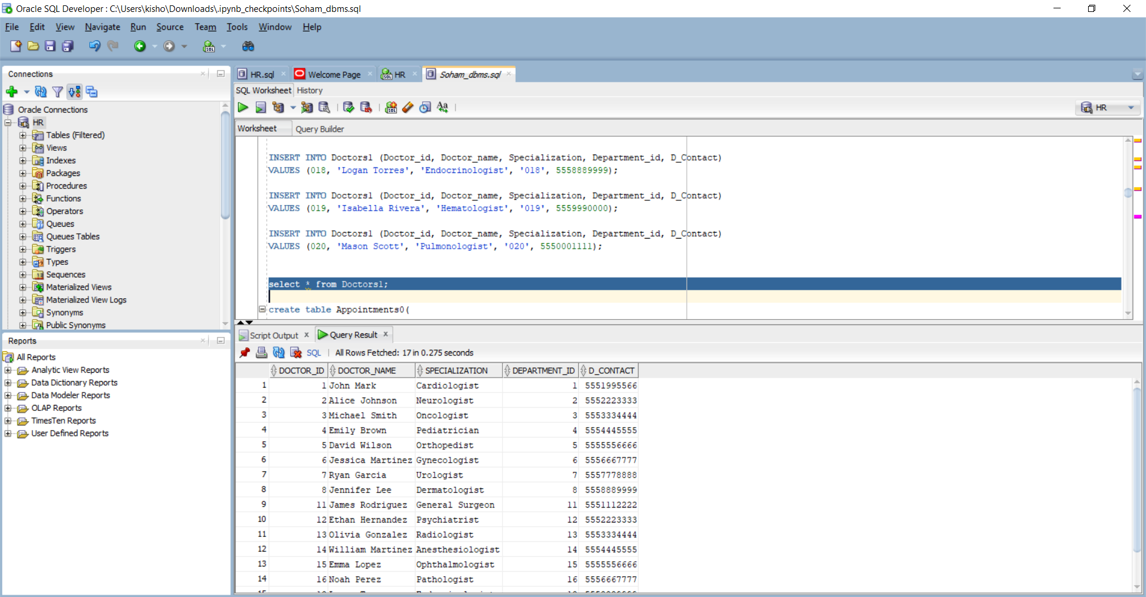

**APPOINTMENTS**

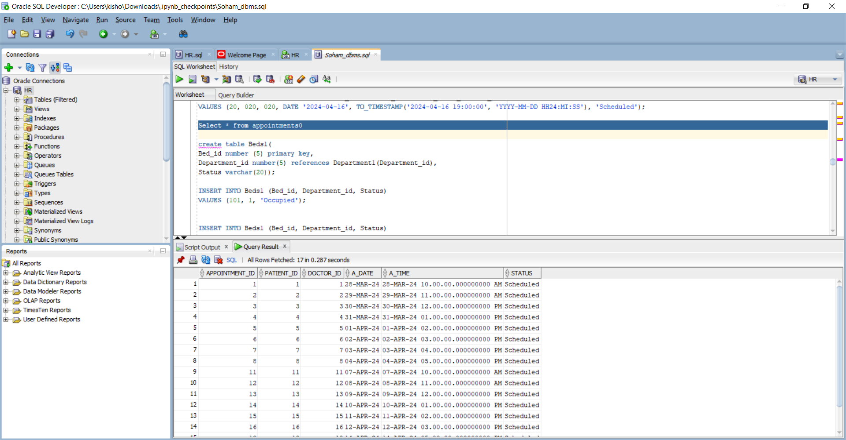

**BEDS**

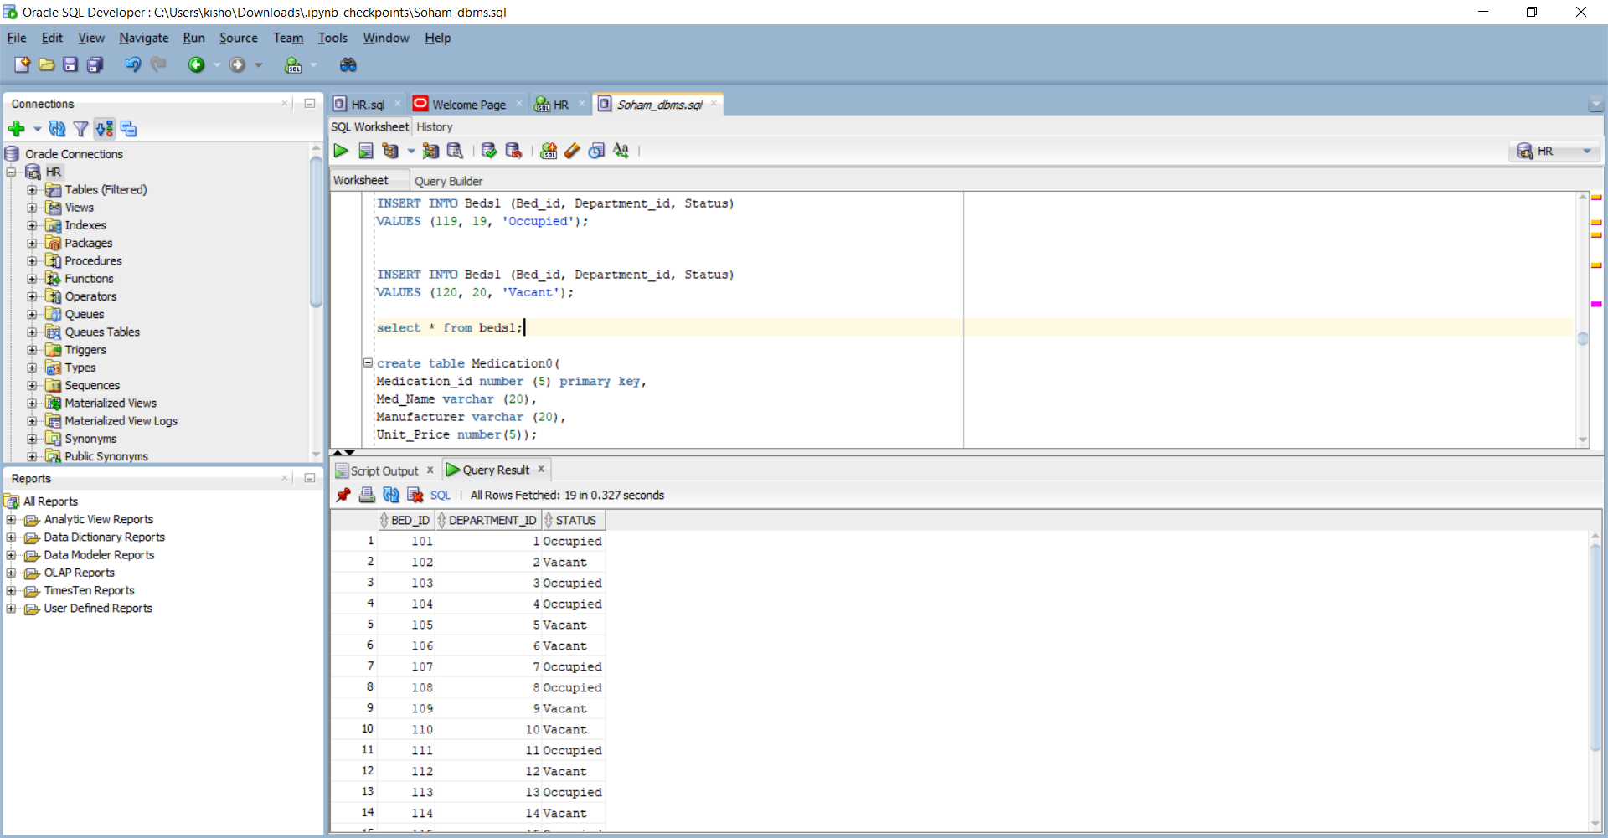

**MEDICATIONS**

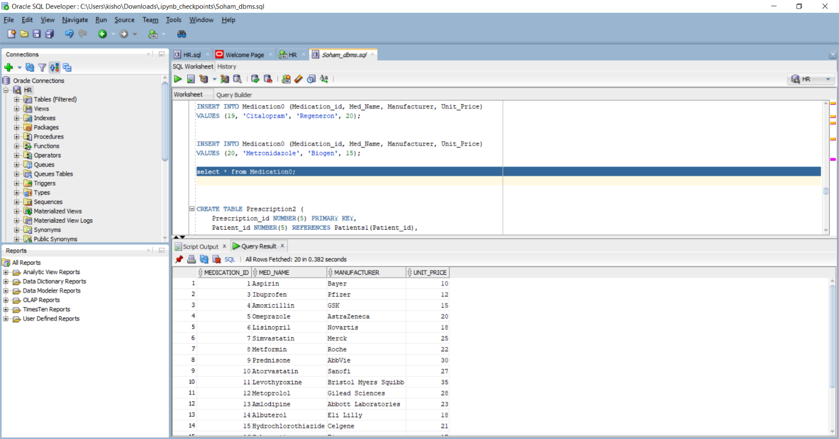

**PRESCRIPTIONS**

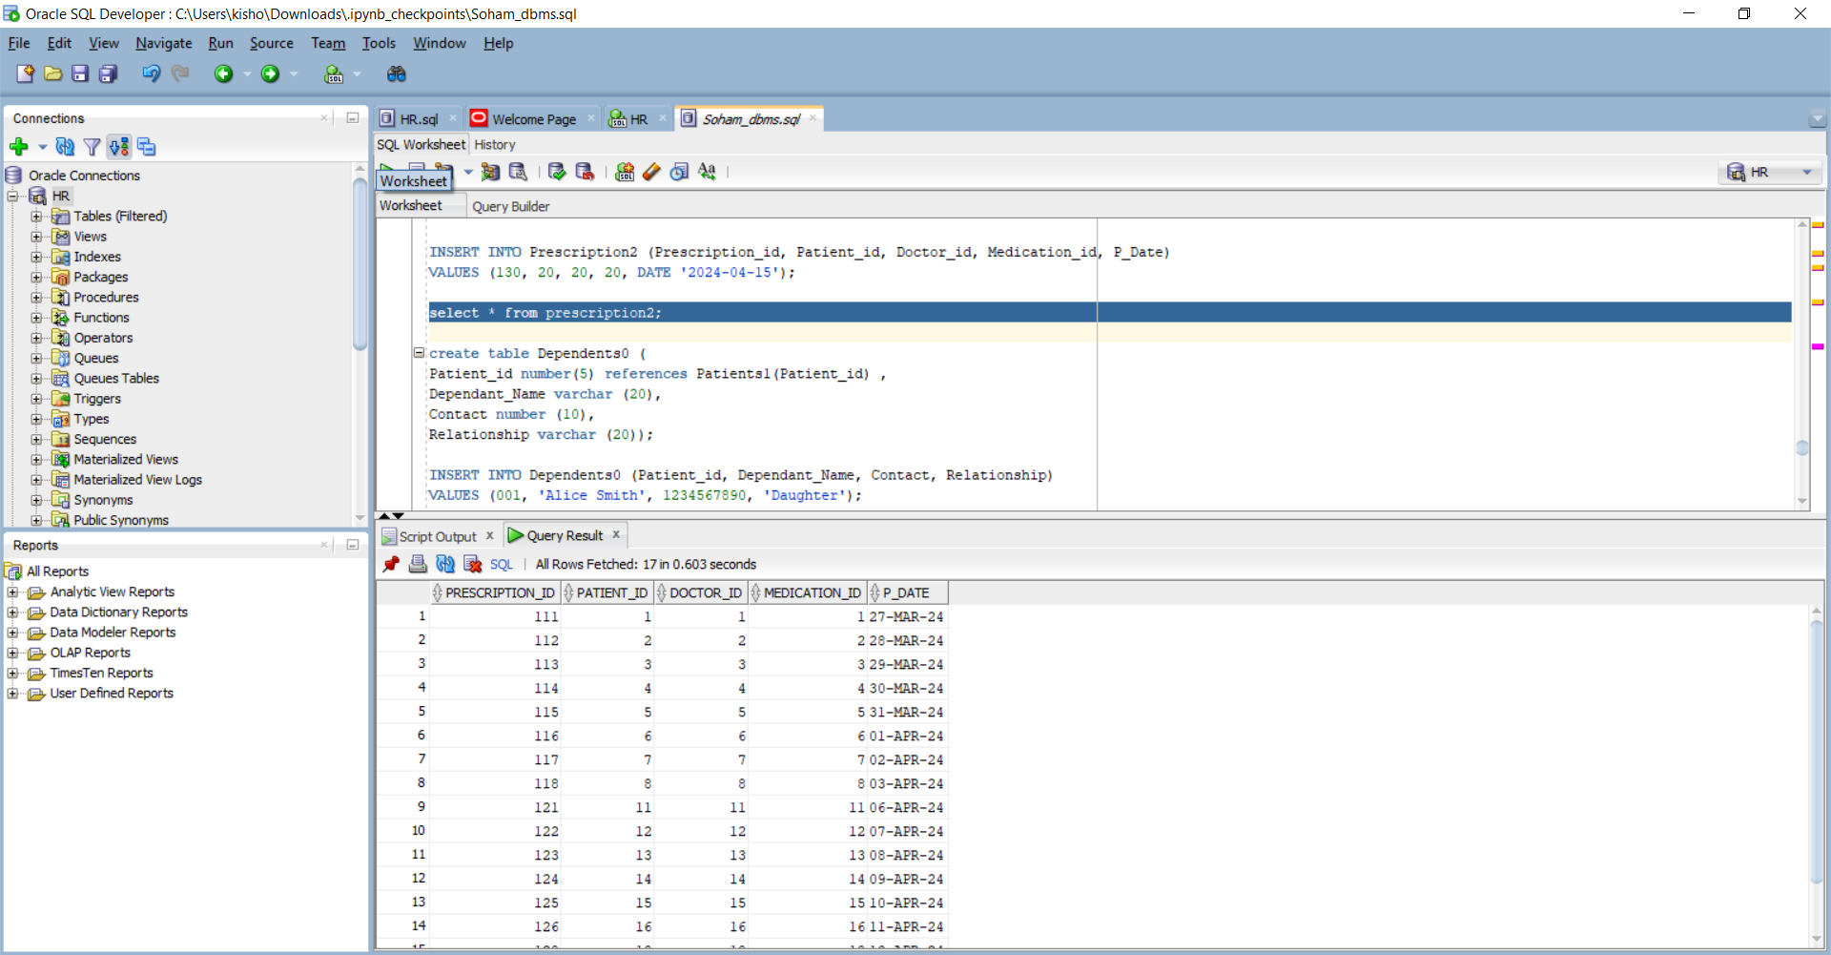

**DEPENDENTS OF**

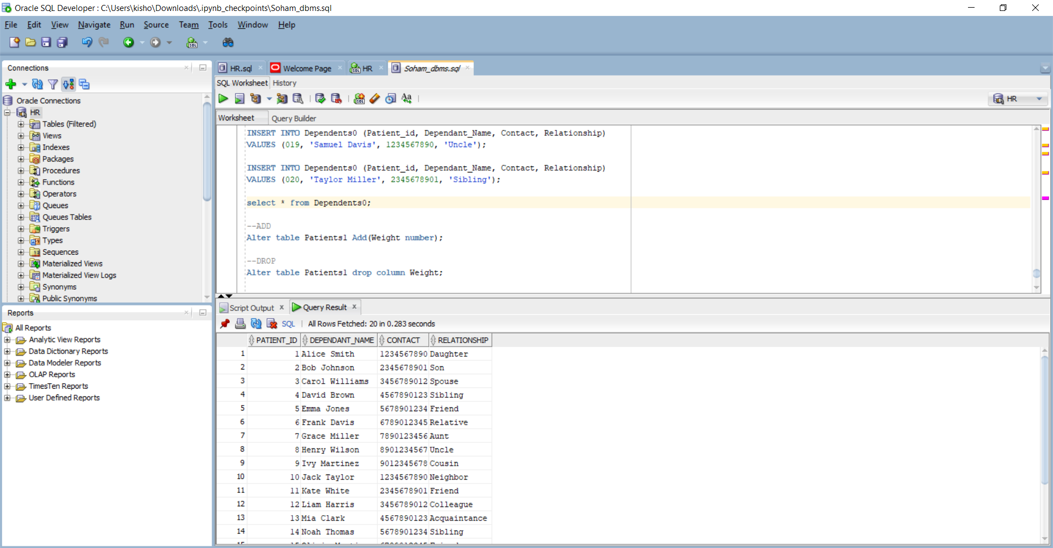

**SQL QUERIES**

**1 . ADDING A COLUMN**

Alter table Patients1 Add(Weight number);

select * from patients1;

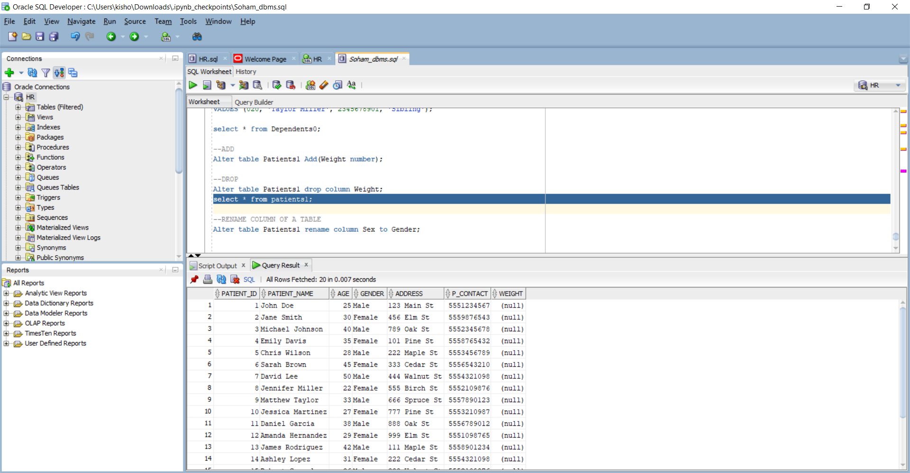

**2 . DROP A COLUMN**

Alter table Patients1 drop column Weight;

select * from patients1;



**3. RENAME A COLUMN OF A TABLE**

Alter table Patients1 rename column Address to Street;

select * from patients1;

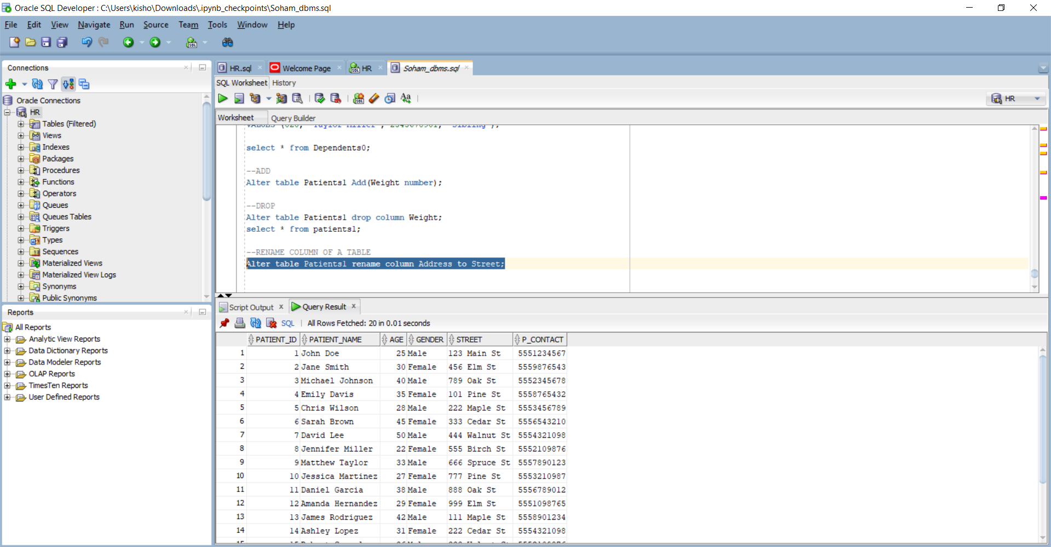

**4 . SELECT STATEMENT AND WHERE CLAUSE**

select * from patients1 WHERE Gender = 'Male';

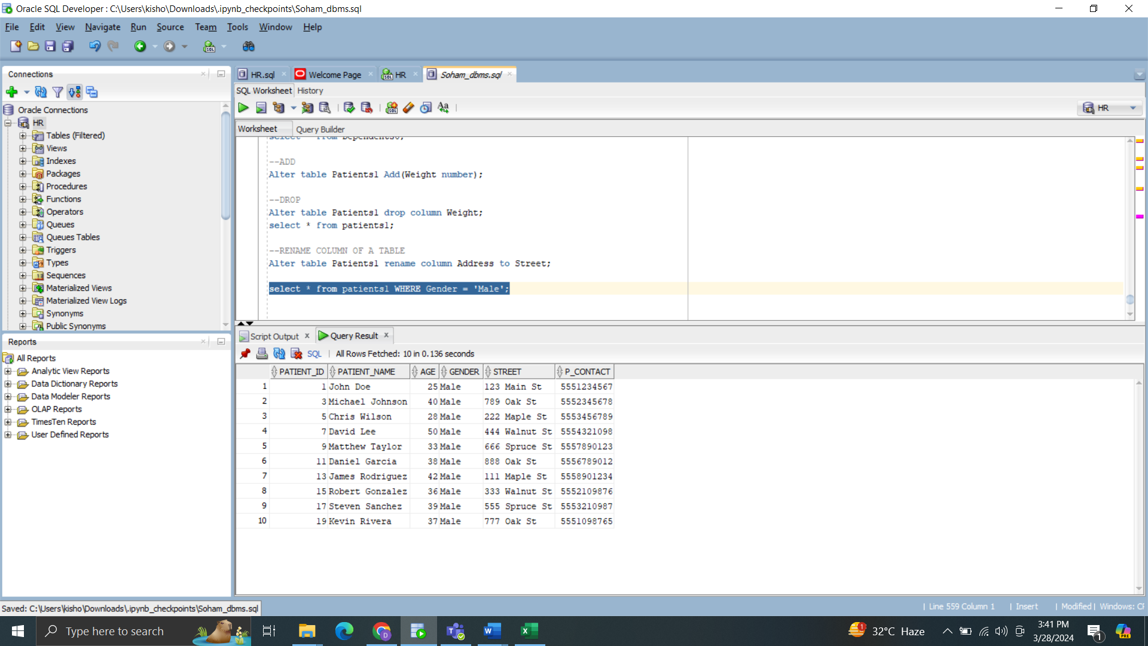

**5 . AND OPERATOR**

**select * from patients1 WHERE Gender = 'Female' and Age>30;**

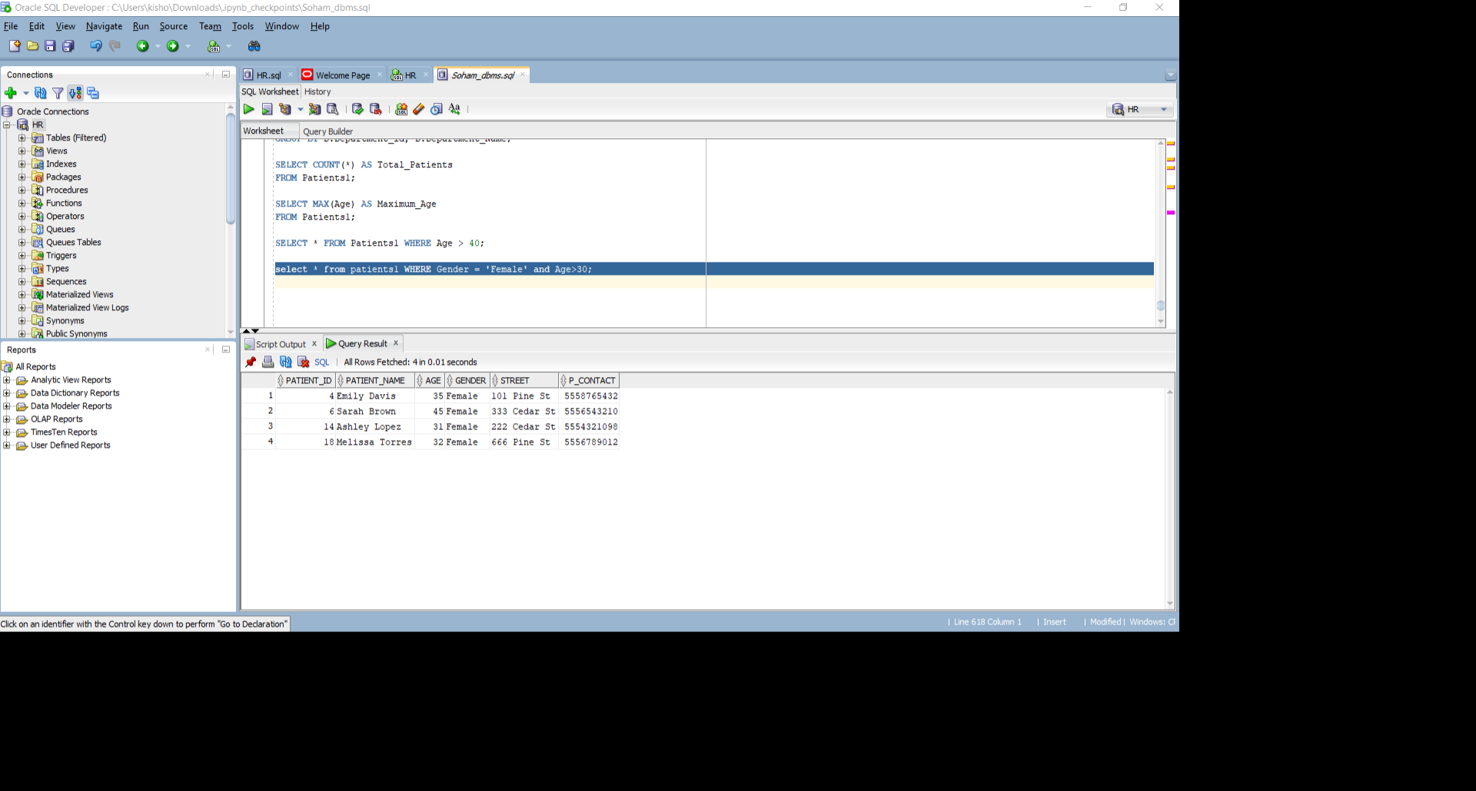

6: **SELECT * FROM Appointments0 WHERE A_Time BETWEEN TIMESTAMP '2024-03-29 09:00:00' AND TIMESTAMP '2024-03-29 12:00:00';**

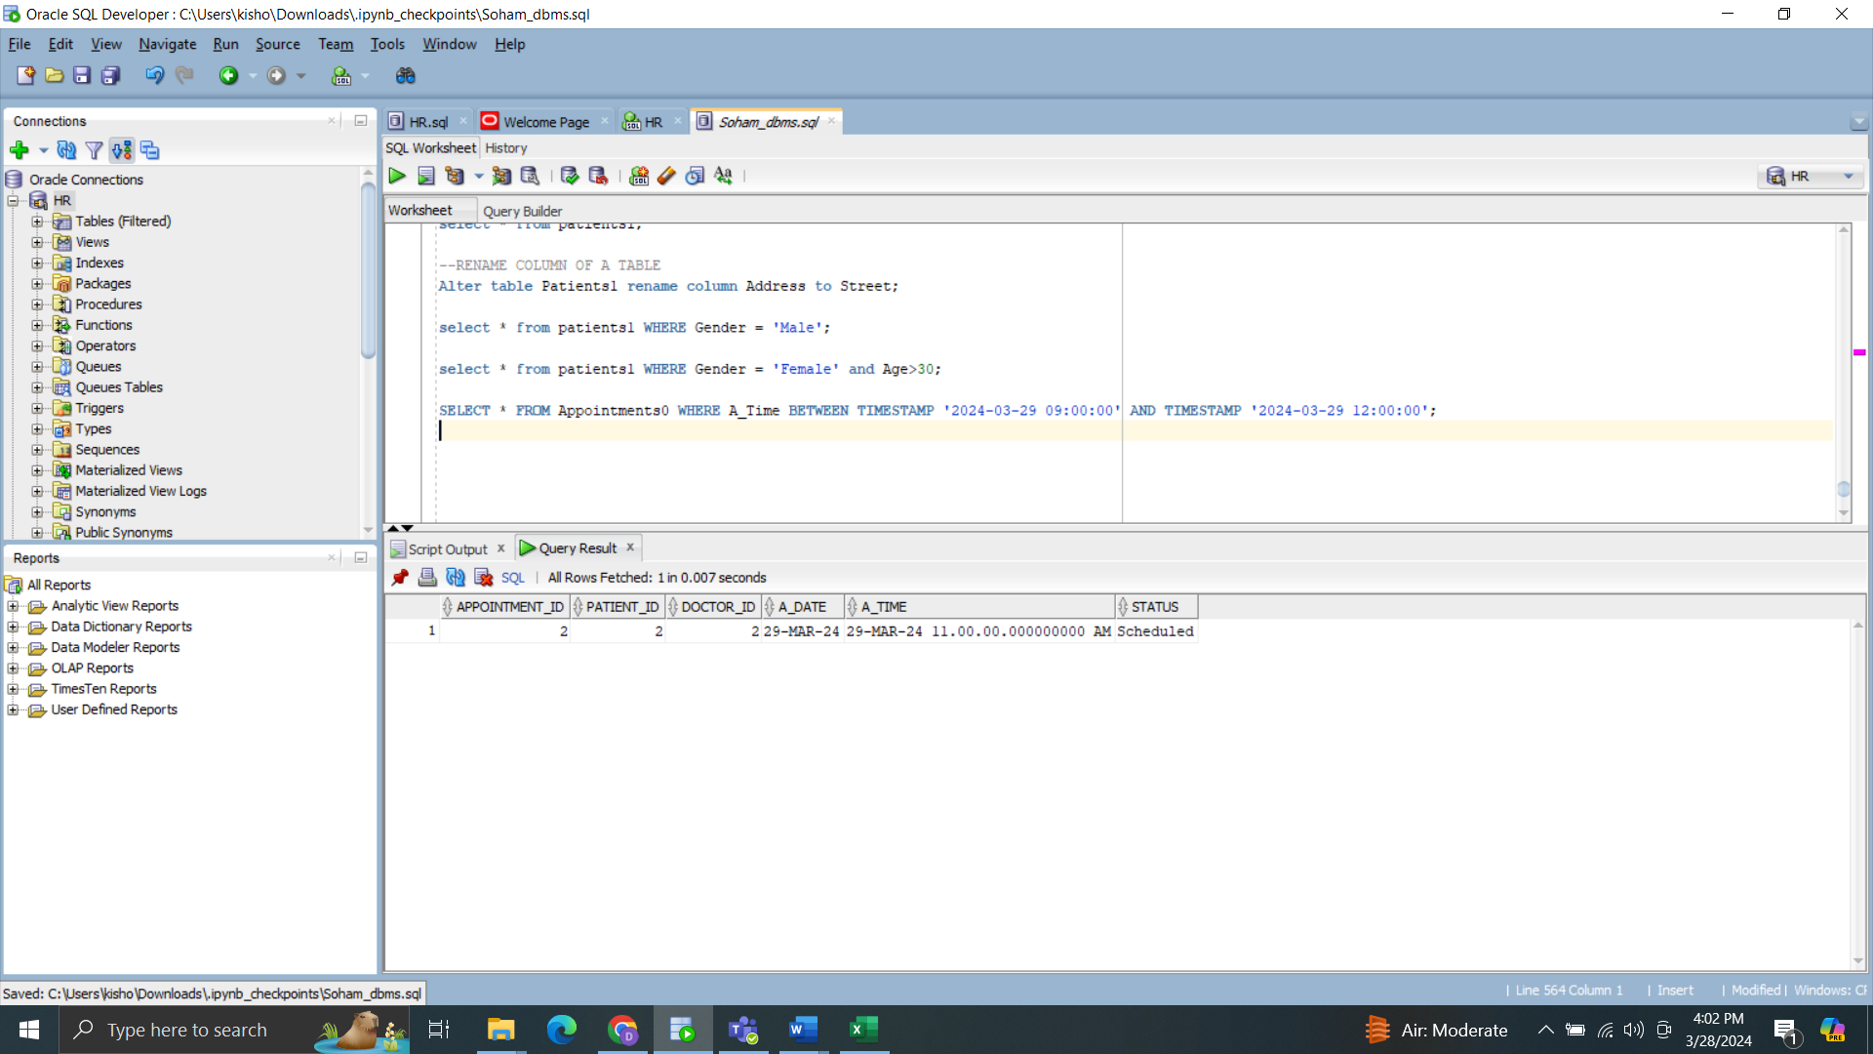

**7. SELECT * FROM Medication0 WHERE Unit_Price < 20;**

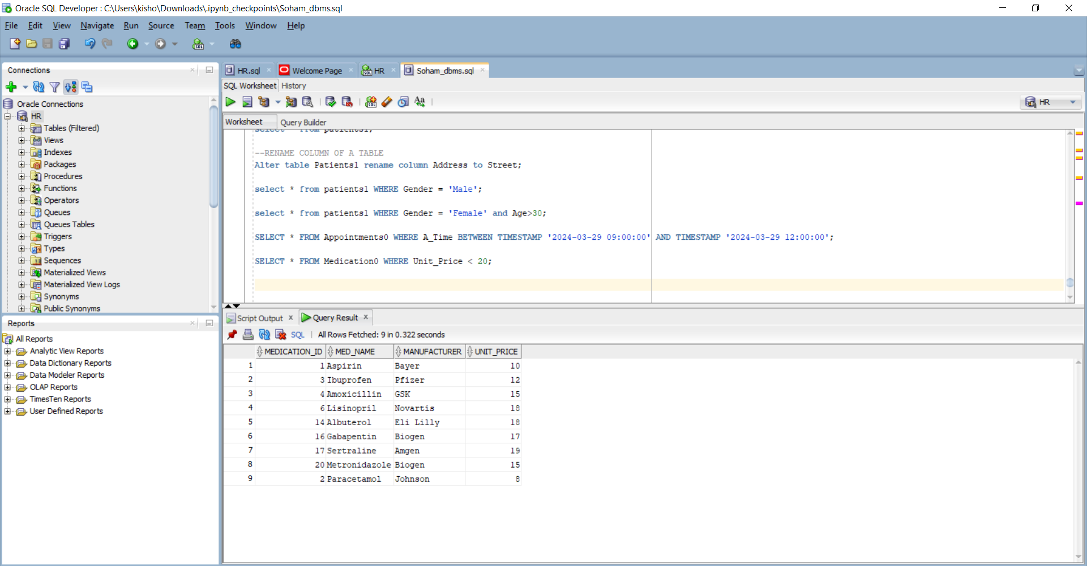

8 **SELECT A.*, P.Patient_name, D.Doctor_name**

**FROM Appointments0 A**

**JOIN Patients1 P ON A.Patient_id = P.Patient_id**

**JOIN Doctors1 D ON A.Doctor_id = D.Doctor_id;**

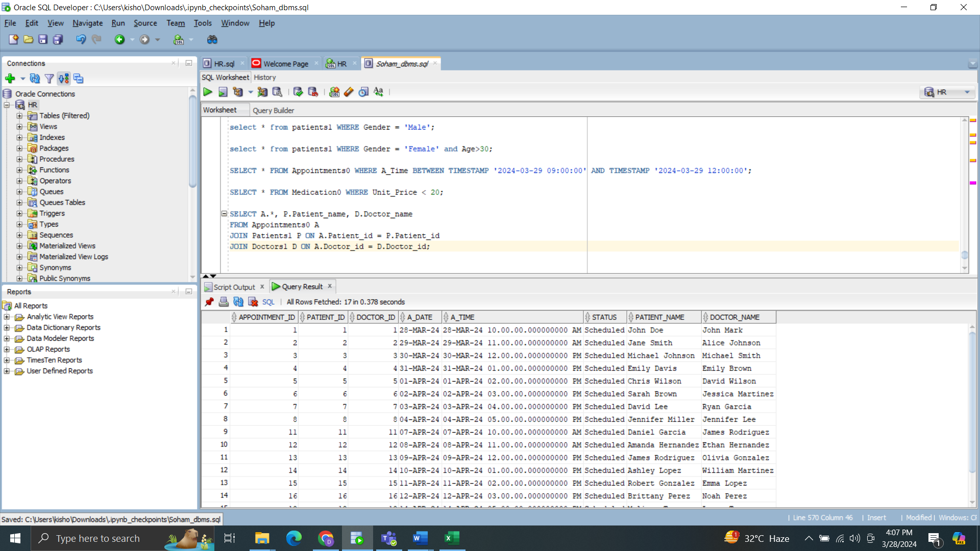

**9. SELECT * FROM Medication0 ORDER BY Unit_Price ASC;**

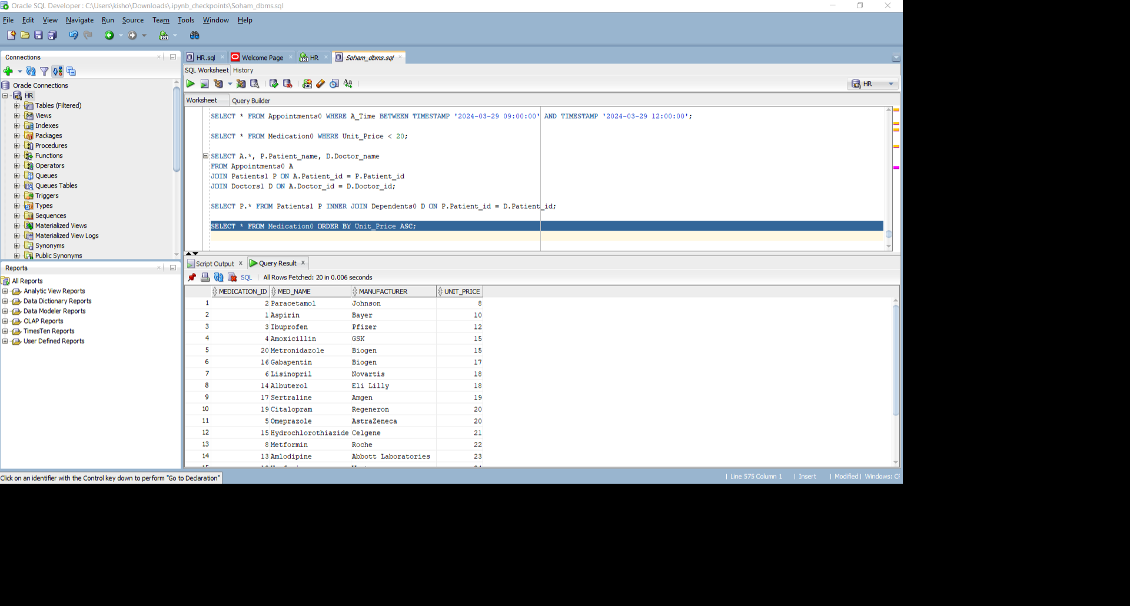

**10 SELECT P.Patient_name, D.Dependant_Name, D.Relationship**

**FROM Patients1 P**

**INNER JOIN Dependents0 D ON P.Patient_id = D.Patient_id;**

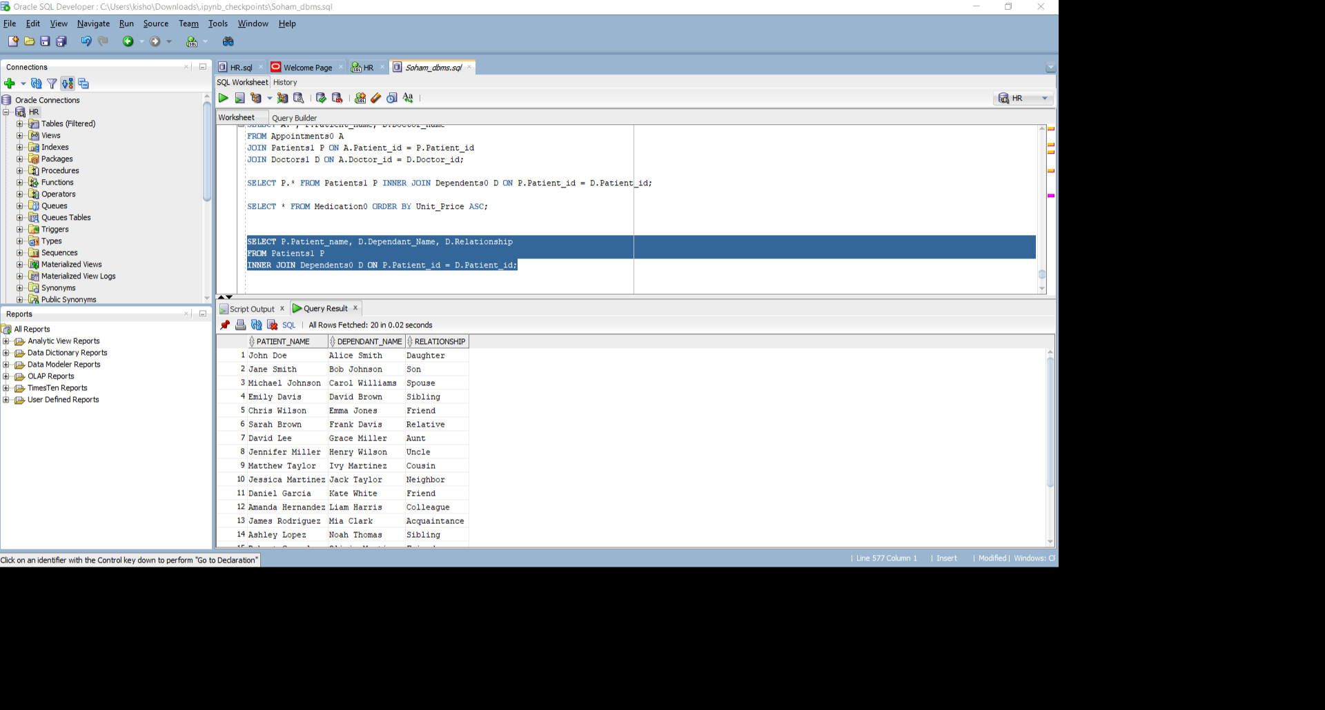

**11 SELECT P.Prescription_id, SUM(M.Unit_Price) AS Total_Cost**

**FROM Prescription2 P**

**JOIN Medication0 M ON P.Medication_id = M.Medication_id GROUP BY P.Prescription_id;**

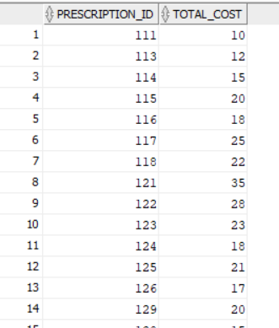

**12**

SELECT AVG(age) AS average_age

FROM Patients1;

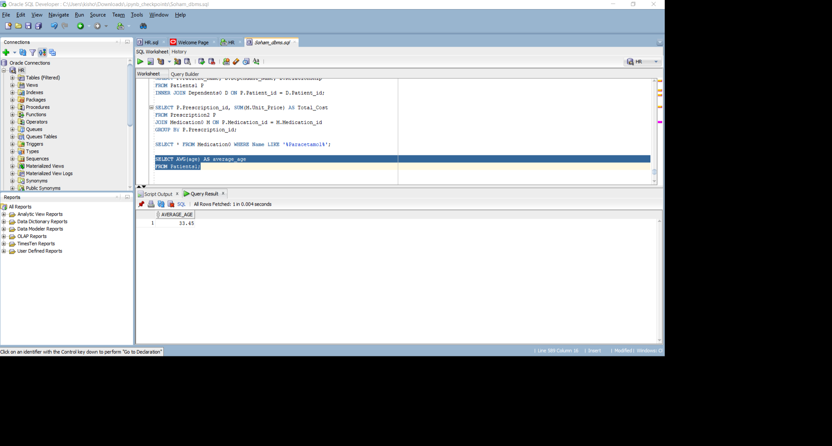

13.

SELECT Gender, COUNT(*) AS patient_count

FROM Patients1

GROUP BY Gender;

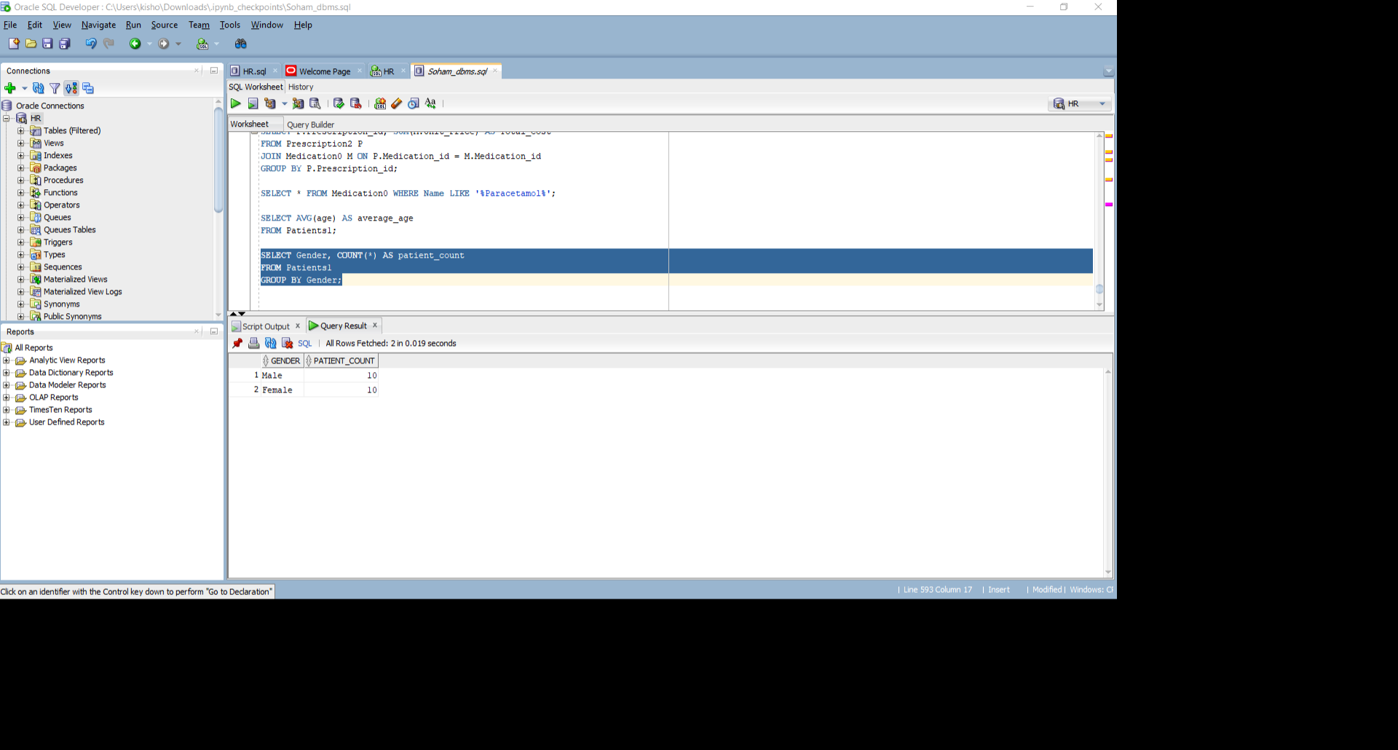

14.

SELECT * FROM Medication0 WHERE Unit_Price > (SELECT AVG(Unit_Price) FROM Medication0);

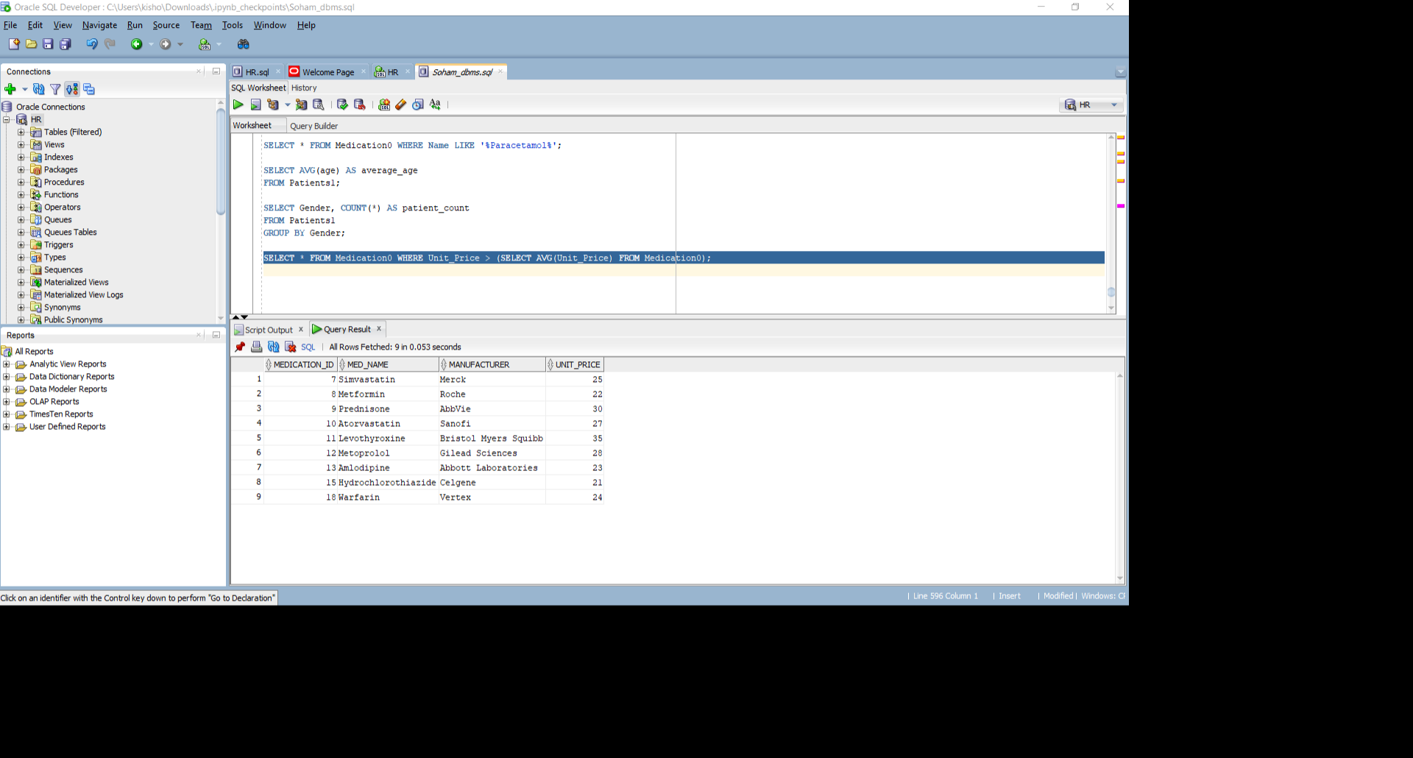

15.

SELECT * FROM Doctors1 WHERE Specialization = 'Cardiologist';

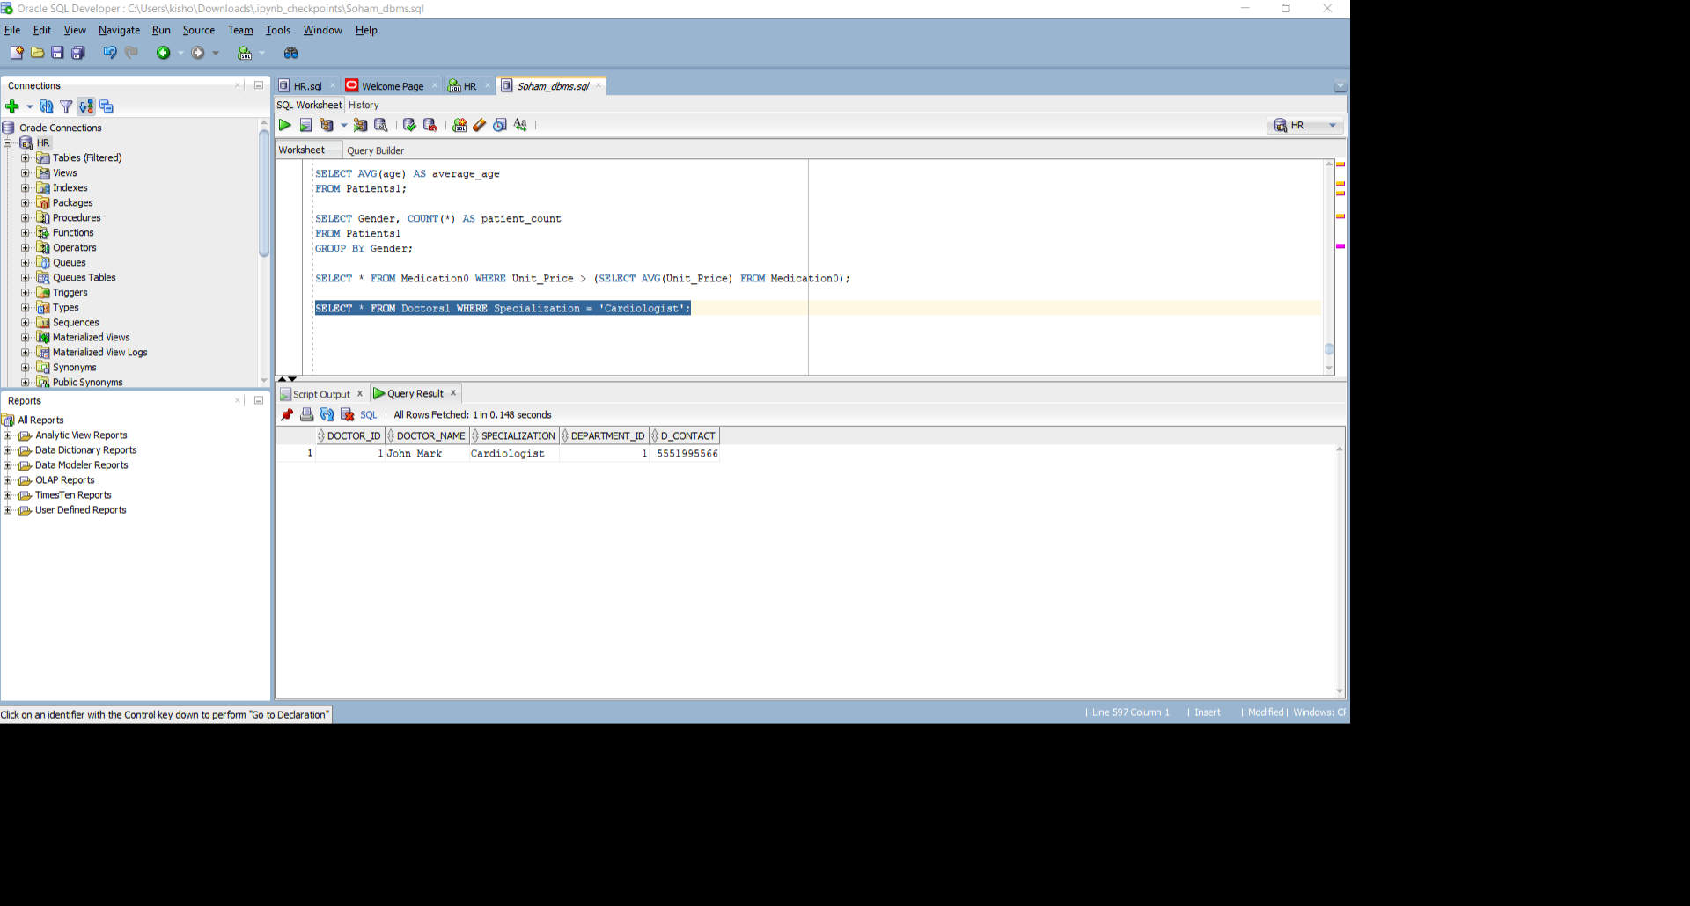

16.

SELECT A.*, P.Age, D.Specialization

FROM Appointments0 A

JOIN Patients1 P ON A.Patient_id = P.Patient_id

JOIN Doctors1 D ON A.Doctor_id = D.Doctor_id;

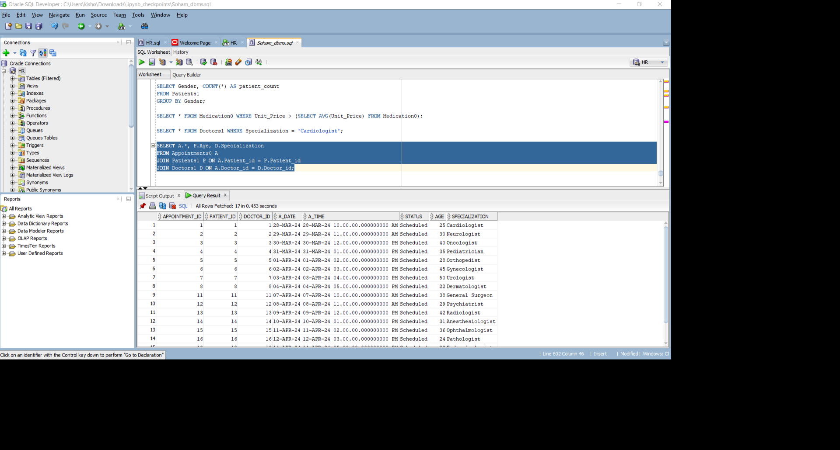

17.

SELECT D.Department_id, D.Department_Name, COUNT(Doc.Doctor_id) AS Num_Doctors

FROM Department1 D

LEFT JOIN Doctors1 Doc ON D.Department_id = Doc.Department_id

GROUP BY D.Department_id, D.Department_Name;

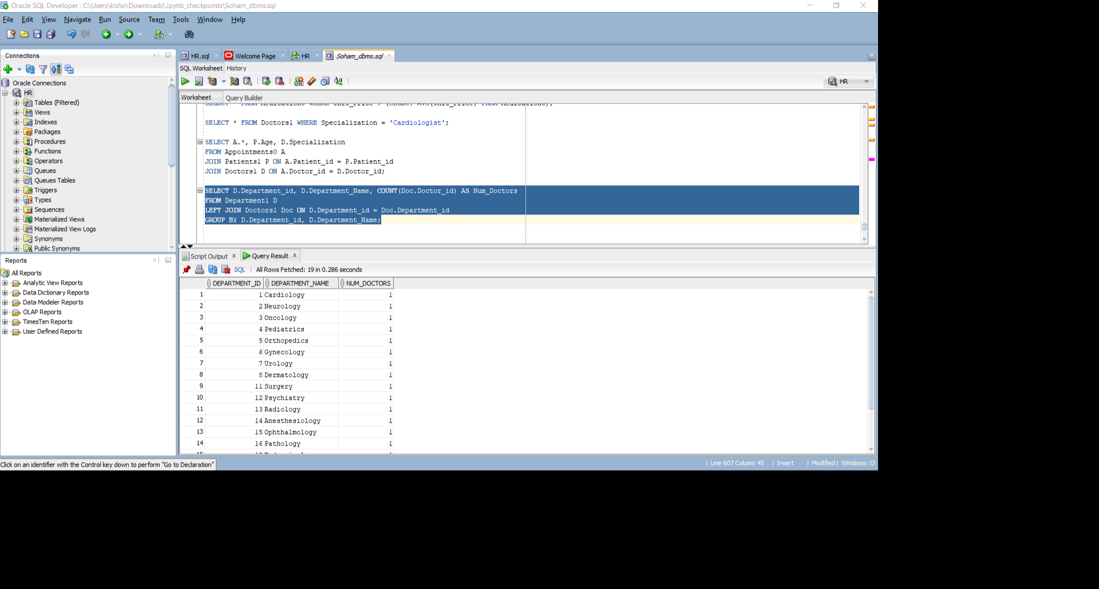

18.

SELECT COUNT(*) AS Total_Patients

FROM Patients1;

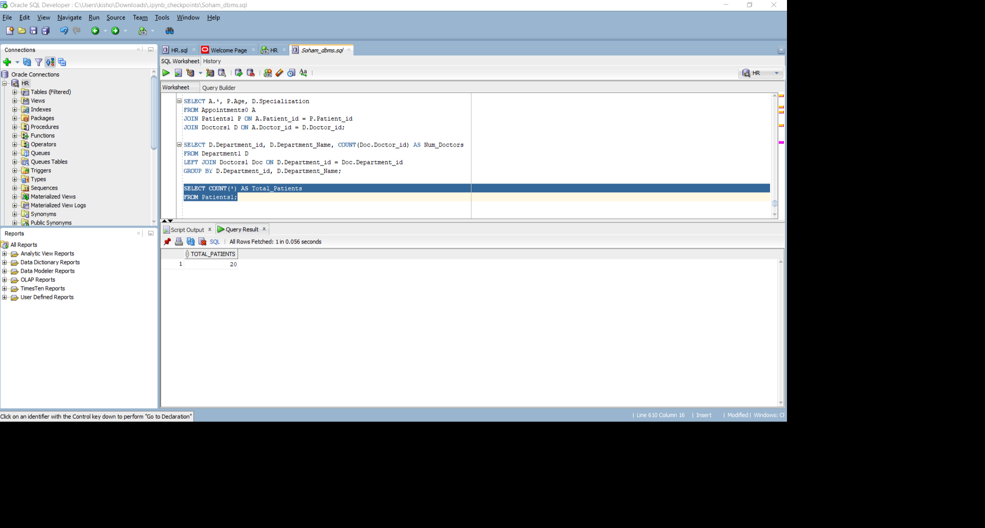

19.

SELECT MAX(Age) AS Maximum_Age

FROM Patients1;

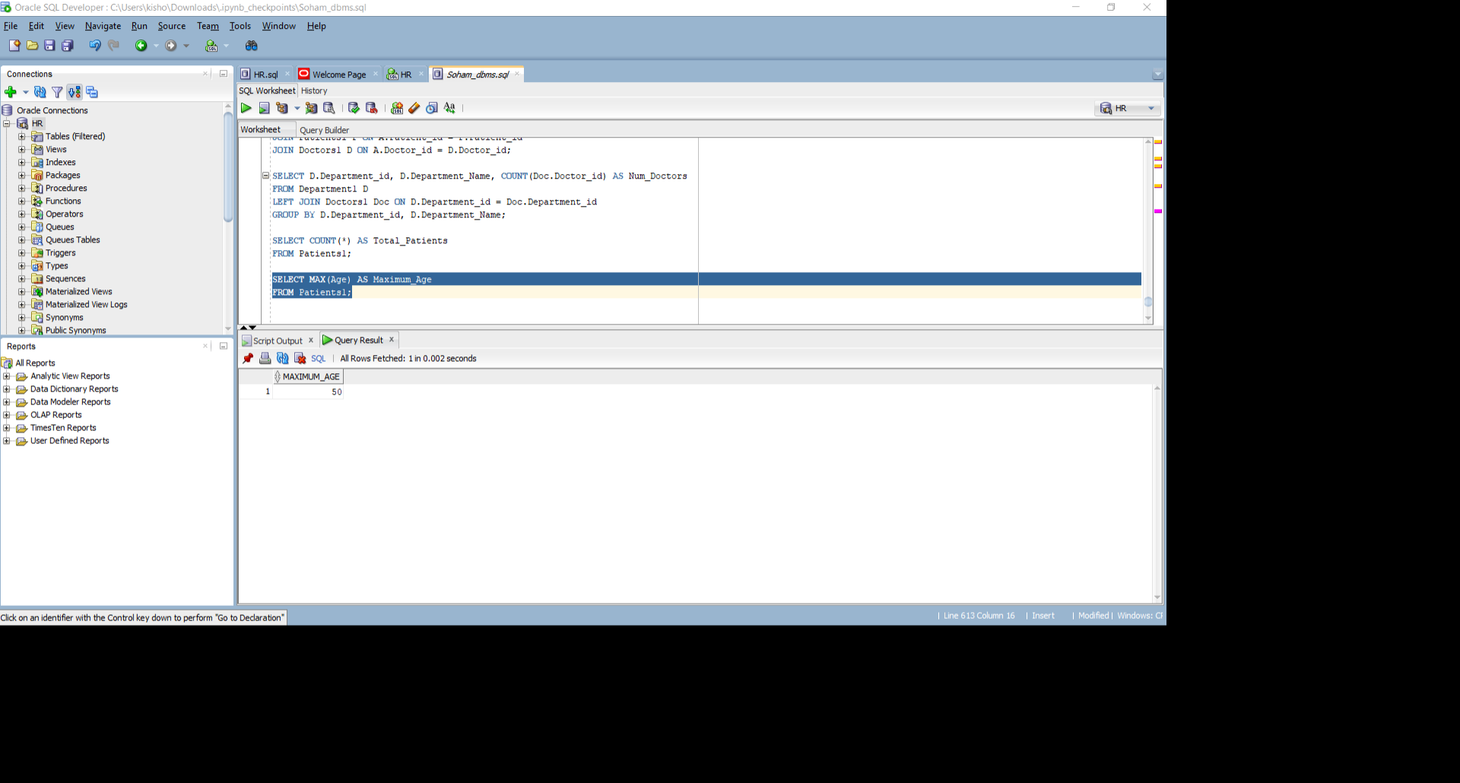

20.

SELECT * FROM Patients1 WHERE Age > 40;

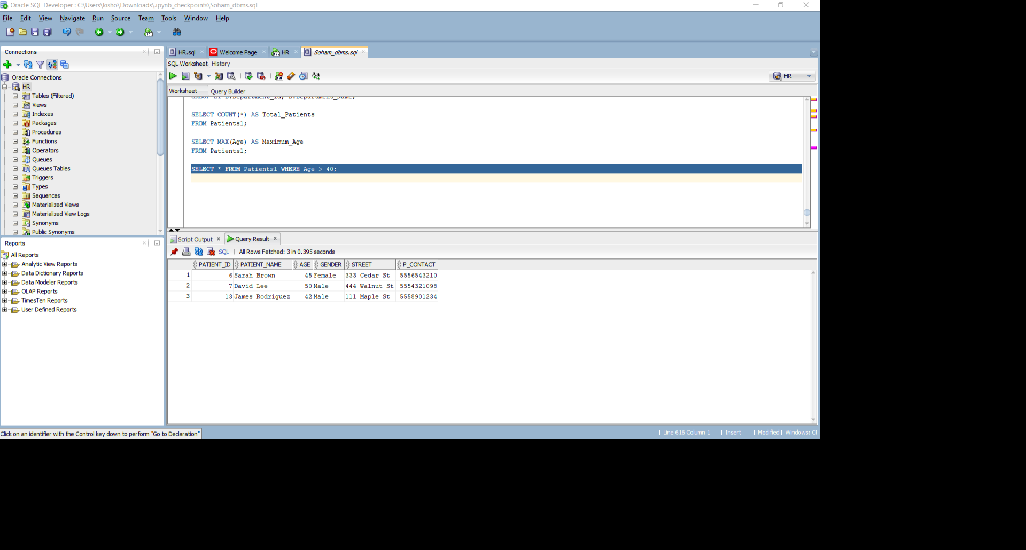

21.

Select * from Dependents0 Where Relationship ='Sibling';

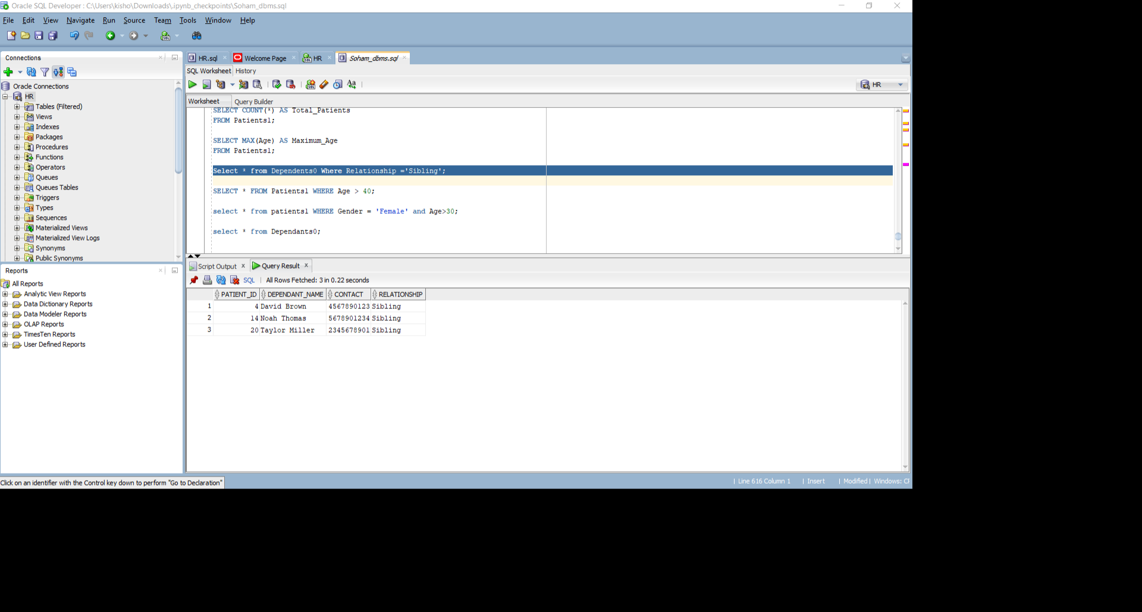

**VI. Project demonstration**

Softwares used – ORACLE SQL DEVELOPER, draw.io, ERDPlus.

Oracle SQL Developer is an Integrated development environment (IDE) for working with SQL in Oracle databases. Oracle Corporation provides this product free; it uses the Java Development Kit.

**VII. Self -Learning beyond classroom**

:

1. Demonstrated Independent Exploration of Advanced SQL Concepts: This emphasizes your initiative in going beyond the prescribed curriculum and exploring more complex SQL functionalities.
2. Successfully Executed Non-Syllabus Queries: This highlights your ability to apply your knowledge to solve problems that weren't explicitly covered in class.
3. Expanded SQL Skillset through Independent Learning: This focuses on your self-directed learning and the resulting expansion of your SQL skillset.
4. Leveraged SQL for Tasks Beyond Course Scope: This showcases your understanding that SQL can be applied in diverse scenarios beyond the classroom setting.

**VIII. Learning from the Project**

* SQL Proficiency: Through practical application in SQL Developer, we enhanced our SQL proficiency by writing complex queries, optimizing performance, and understanding different SQL constructs.
* Database Design: We learnt about database design principles such as normalization, entity-relationship modeling, and designing efficient schemas to meet project requirements.
* Data Modeling: We gained experience in creating and modifying data models using tools like SQL Developer Data Modeler. We understood how to represent real-world entities, attributes, and relationships effectively.
* Indexing and Optimization: We learnt how to optimize database performance by creating and managing indexes, analyzing query execution plans, and identifying bottlenecks.
* Data Integrity: We understood the importance of enforcing data integrity constraints such as primary keys, foreign keys, unique constraints, and check constraints to maintain data quality and consistency.
* Data Manipulation: Practice manipulating data through SQL statements including INSERT, UPDATE, DELETE, and MERGE operations, and understand the impact of these operations on database integrity.
* Error Handling and Debugging: We enhanced your troubleshooting skills by identifying and resolving common database errors, implementing error handling mechanisms in SQL code, and effectively debugging queries and procedures.

**IX. Challenges Faced**

* Syntax Errors: Dealing with syntax errors in SQL queries required careful debugging and troubleshooting.
* Data Integrity: Ensuring data integrity posed challenges, especially when defining constraints and relationships between tables.
* Performance Optimization: Optimizing query performance demanded experimentation with indexing and query structure to enhance speed and efficiency.
* Complex Queries: Writing complex queries to retrieve specific data required a deep understanding of SQL functionality and logic.
* Compatibility Issues: Addressing compatibility issues between different SQL dialects or database management systems added complexity to the process.
* Resource Management: Managing system resources effectively to prevent slowdowns or crashes during database creation and data insertion was crucial.
* Security Concerns: Implementing security measures to protect sensitive data and prevent unauthorized access required careful consideration and planning.

**X. Conclusion**

In conclusion, the hospital data management project in SQL presented a comprehensive overview of database design, implementation, and management within the context of a healthcare setting. Through this project, several key learnings and challenges were encountered, contributing to a deeper understanding of database management systems and their practical applications.

The project involved various stages, including conceptualizing the database schema, defining entities and their attributes, establishing relationships between entities, implementing data integrity constraints, and optimizing queries for efficient data retrieval and manipulation. Throughout the project, the importance of data accuracy, consistency, and security was emphasized, reflecting the critical role of healthcare data in patient care and decision-making.

Despite the challenges faced, such as complexity in database design, query optimization, and concurrency control, the project provided valuable insights into best practices for database development and administration. Through hands-on experience with SQL Developer and other tools, participants gained proficiency in data modeling, SQL query writing, performance tuning, and error handling, enhancing their skills as database developers and administrators.

Looking ahead, the knowledge and experience gained from this project can be applied to future endeavors in database management, whether in healthcare or other domains. By leveraging the principles and techniques learned, stakeholders can continue to refine and improve their database systems to meet evolving requirements and deliver optimal outcomes for patients, healthcare providers, and other stakeholders.